Create a simple script file and push it to repo. Create a project in Jenkins connected to your GitHub repository. When a commit is made to your repo, automatically build must get triggered from Jenkins and the output must be shared to me via email.

Techstacks needs to be used

AWS EC2

Github

Jenkins

Note: I already installed Jenkins on my EC2 instance hosted in AWS and I am connecting through its public IP (refer Jenkins Task 1 for installation of the same.)

Syntax: http://<EC2-Public-IP>:8080

http:// 3.17.129.234:8080

Step 1: Login to your Jenkins with the username and password created at the beginning.

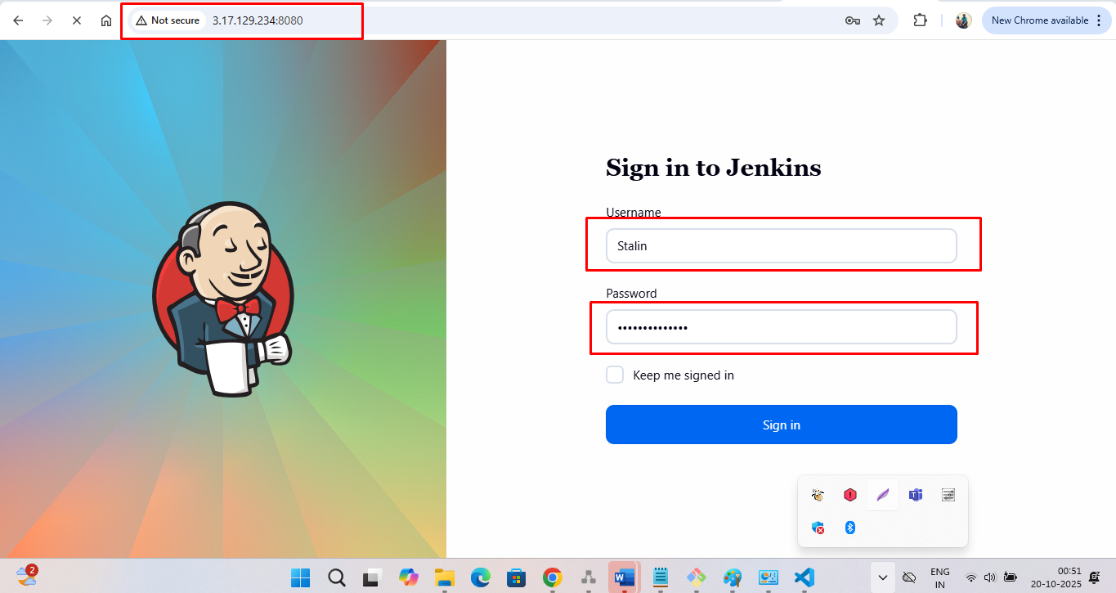

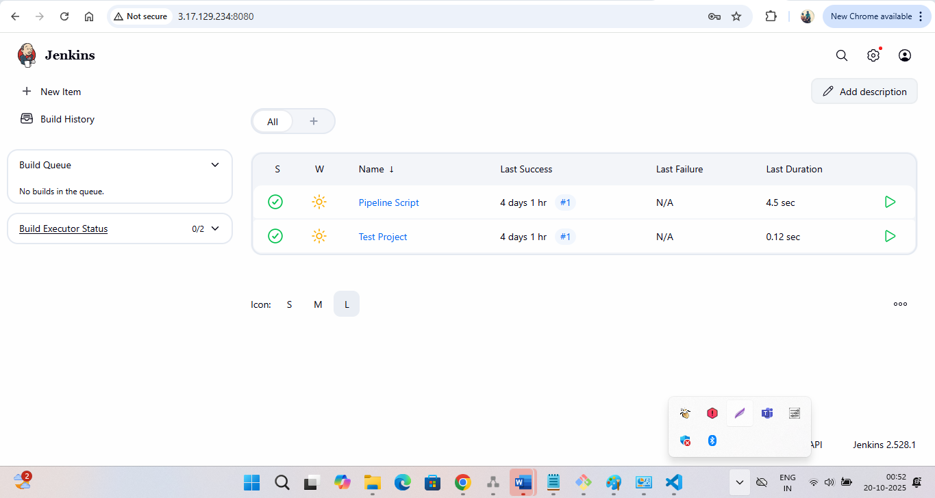

Step 2: Create a GitHub repository.

Create two files locally → hello.sh and Jenkinsfile

In the hello.sh, enter the below script.

echo '#!/bin/bash

echo "Hello from Jenkins on AWS EC2!"

date

' > hello.sh

chmod +x hello.sh

In jenkins-aws-repo, enter the below script.

pipeline {

    agent any

    stages {

        stage('Build') {

            steps {

                sh './hello.sh > output.txt'

            }

        }

    }

    post {

        success {

            emailext (

                subject: "Jenkins Build Successful - ${env.JOB_NAME}",

                body: "Build completed successfully.\n\nOutput attached.",

                to: "your-email@example.com",

                attachmentsPattern: "output.txt"

            )

        }

        failure {

            emailext (

                subject: "Jenkins Build Failed - ${env.JOB_NAME}",

                body: "Build failed. Check Jenkins logs.",

                to: "your-email@example.com"

            )

        }

    }

}

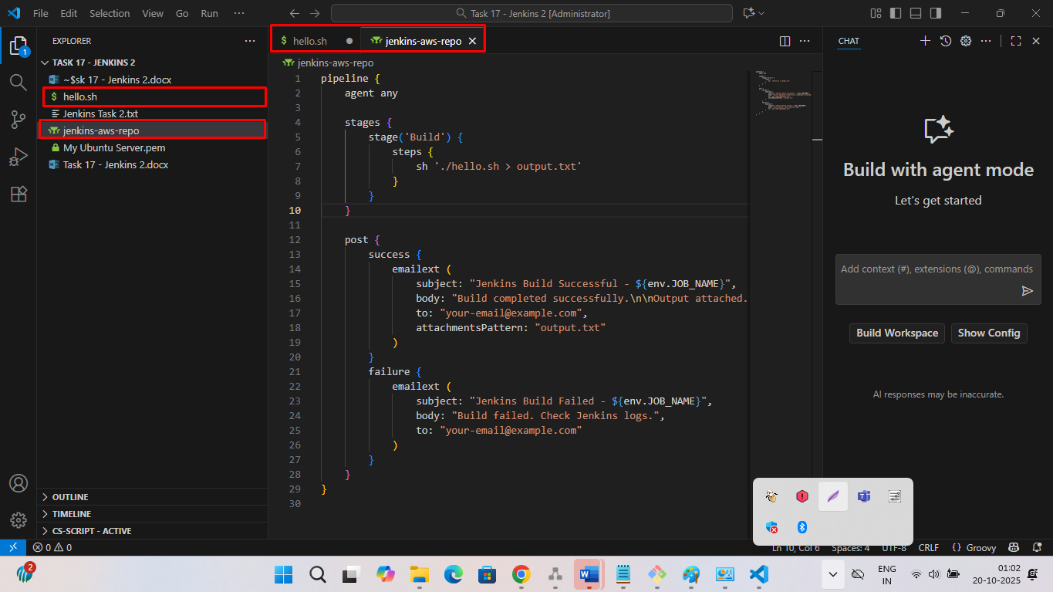

Step 3: Push these codes to GitHub repository.

cmd: git init - Initializes a new Git repository

cmd: git add . - Adds **all files** in the current directory

cmd: git commit -m "Initial commit with Jenkinsfile" - Saves the staged changes in Git

cmd: git remote add origin <https://github.com/StalinK1/Jenkins-demo.git> - Links your local repository to a **remote GitHub repository**.

cmd: git push --set-upstream origin master - Pushes your local master branch to the remote repository (origin) and sets it as the default upstream branch.

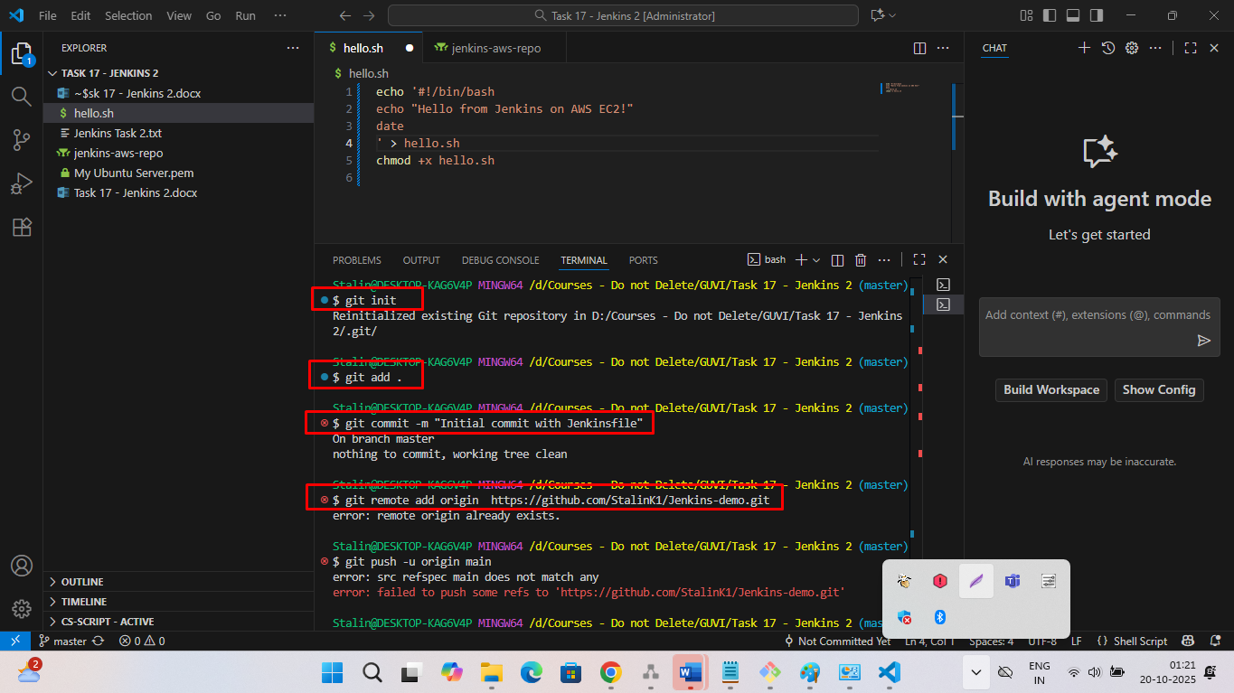

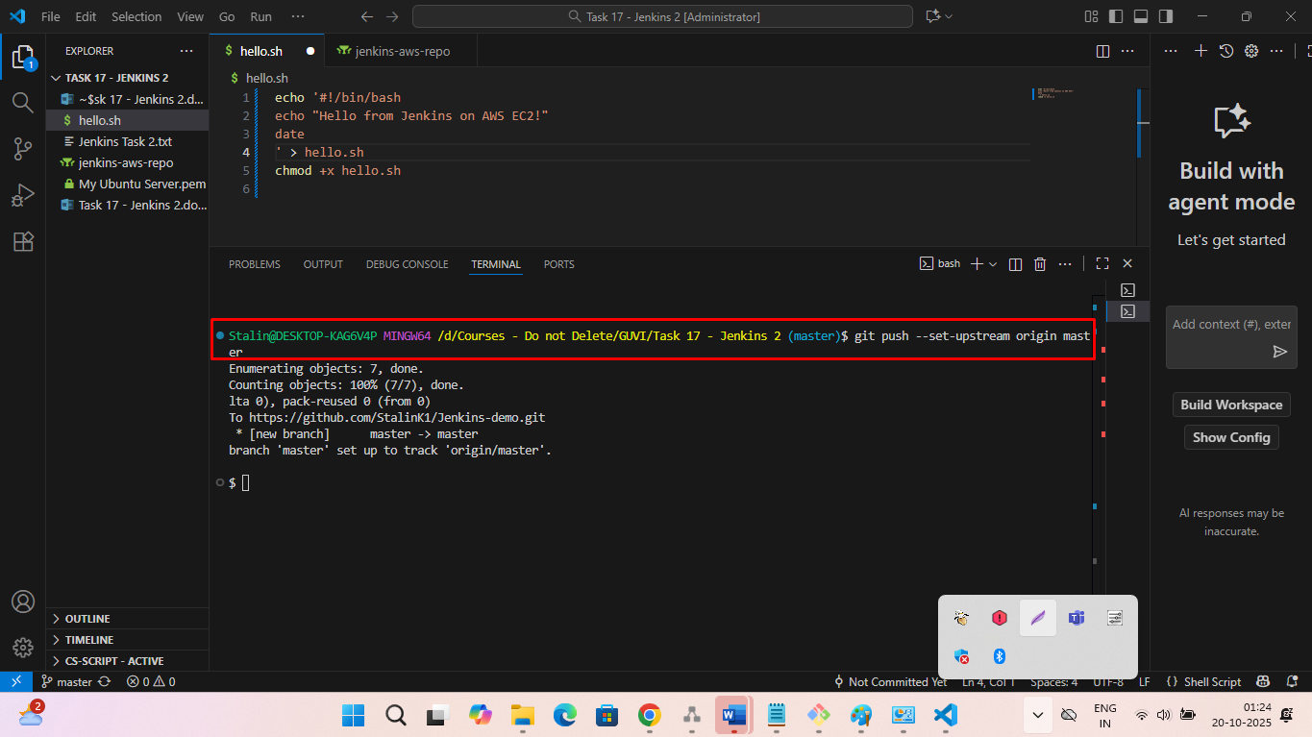

Note : Codes pushed to your Git Hub Repository (I already created a Git Hub repository.)

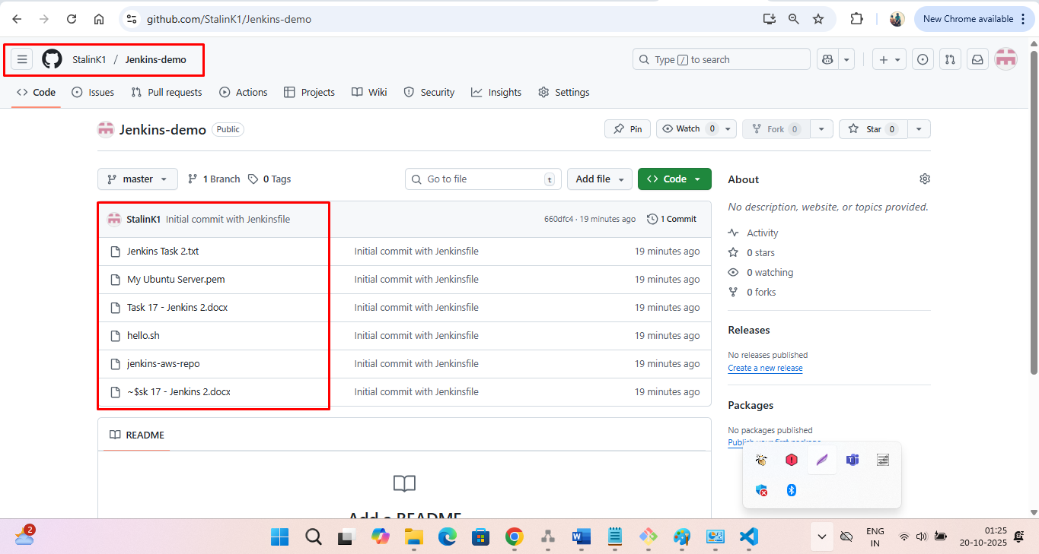

Step 4: Connect GitHub to Jenkins.

4.1 : In Jenkins Dashboard → New Item → Pipeline and click OK.

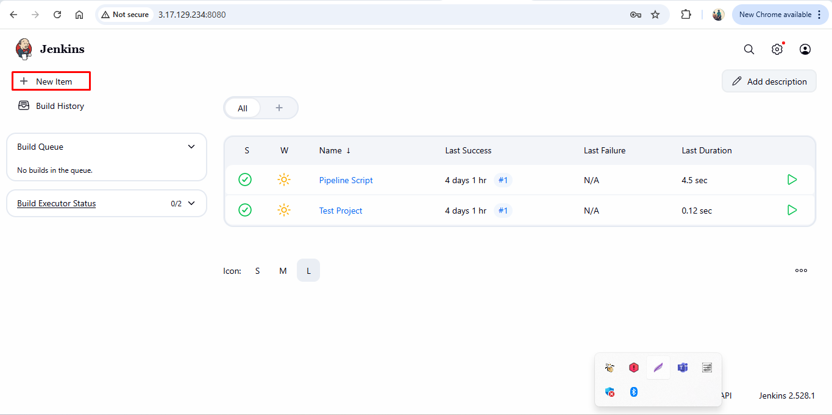

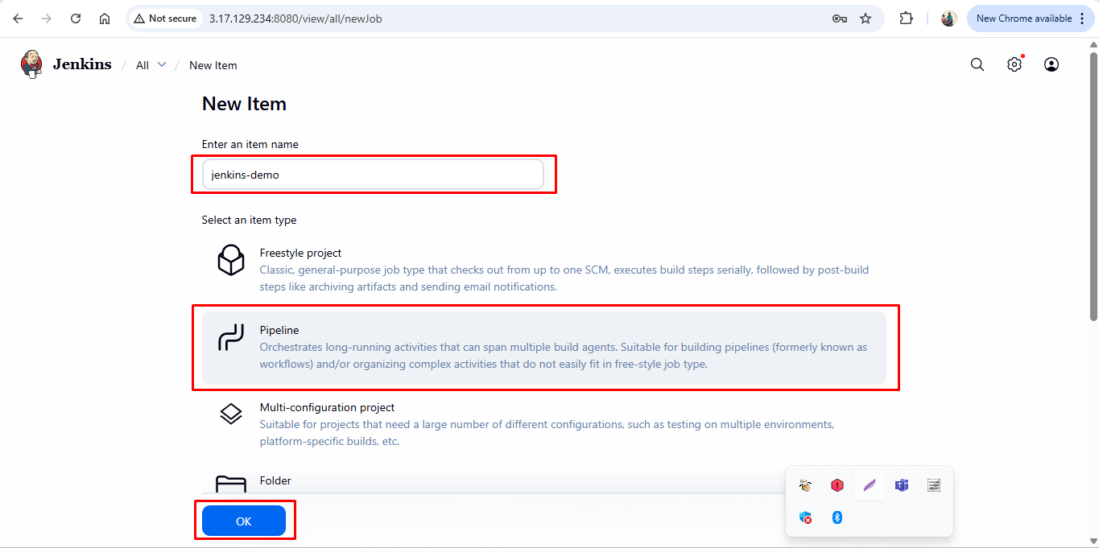

4.2:

In Pipeline Definition, choose Pipeline script from SCM

SCM: Git

Repo URL: <https://github.com/StalinK1/Jenkins-demo.git>

Branch: */master

Script path: Jenkinsfile

Save the build.

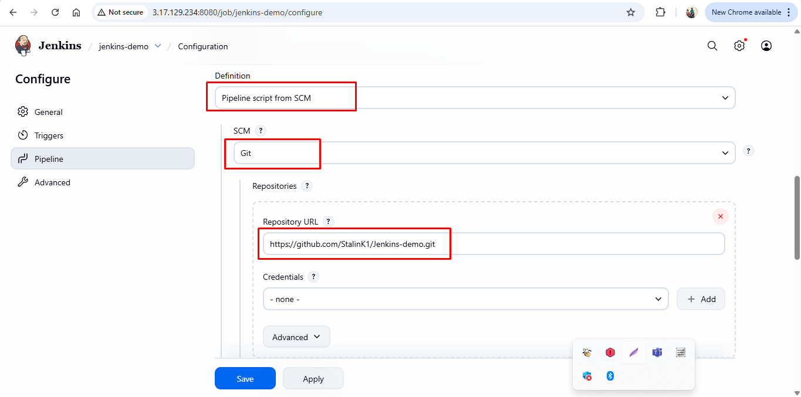

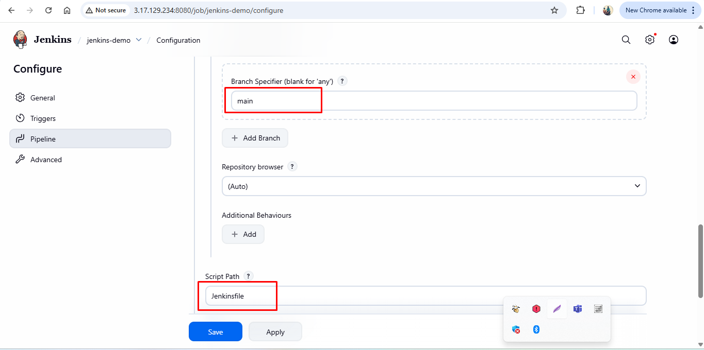

Step 5: Auto Trigger from GitHub

In GitHub Repo → Settings → Webhooks → Add Webhook

You need to verify you e-mail.

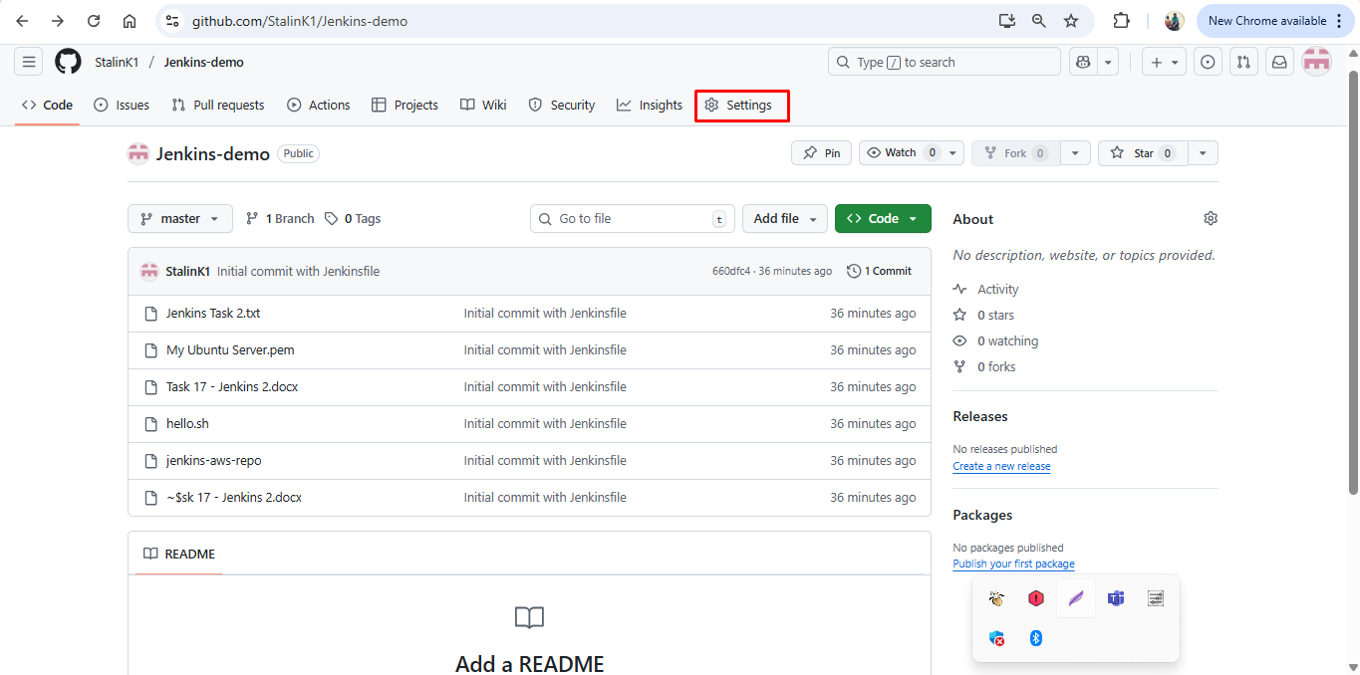

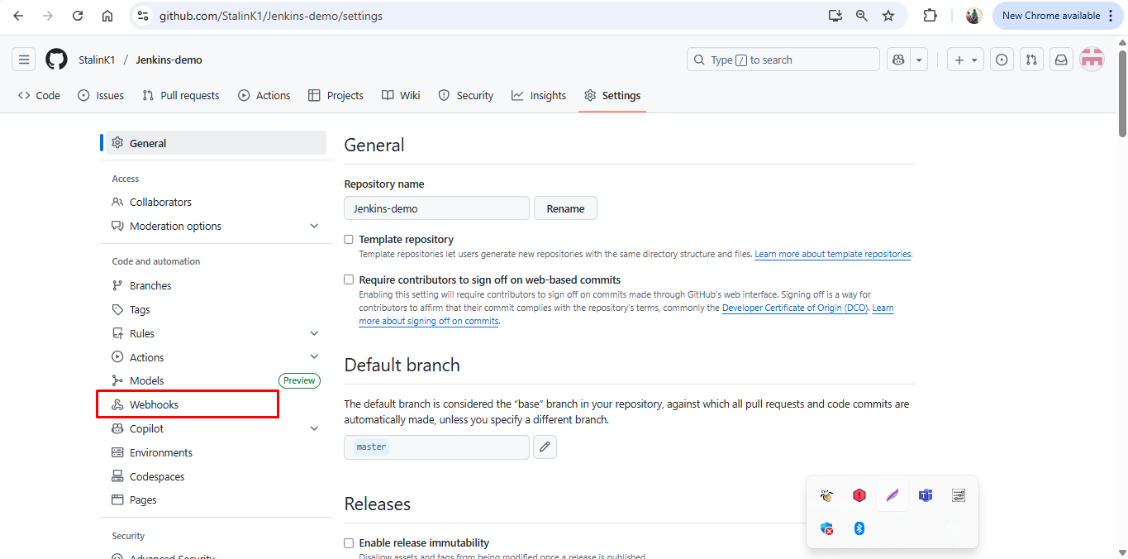

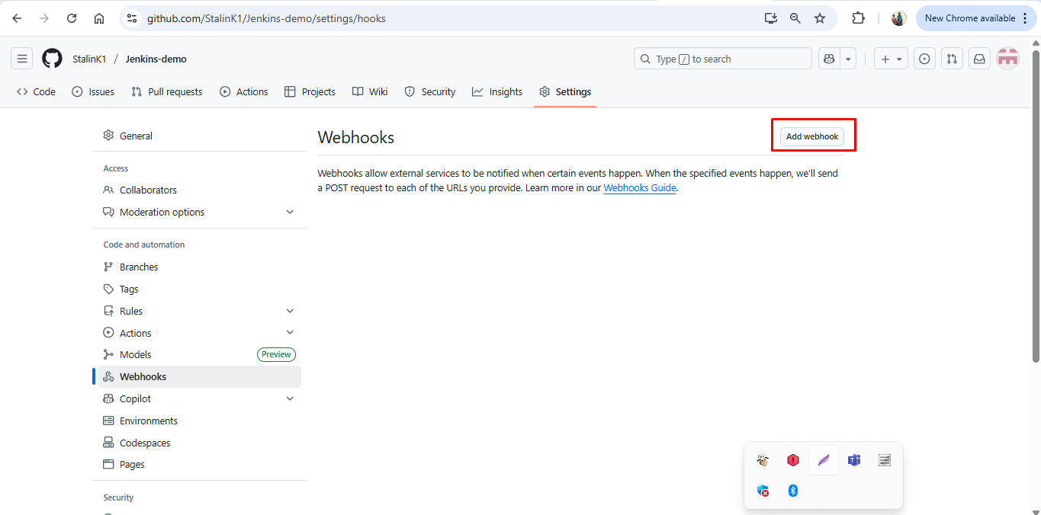

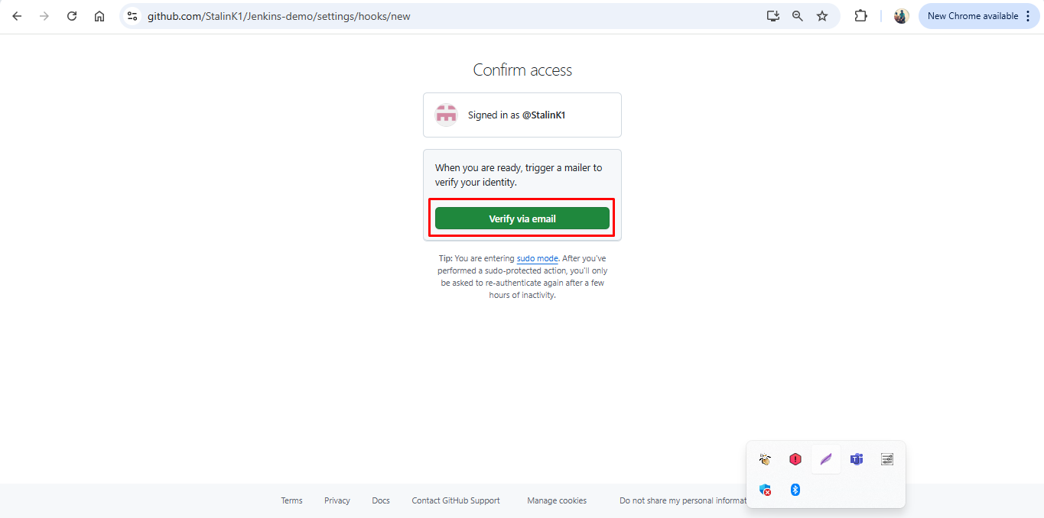

Step 5.1:

Give the Payload URL: http://<EC2-Public-IP>:8080/github-webhook/

<http://3.17.129.234:8080/github-webhook/>

Content type: application/json

Trigger: Just the push event

Click Add Webhook

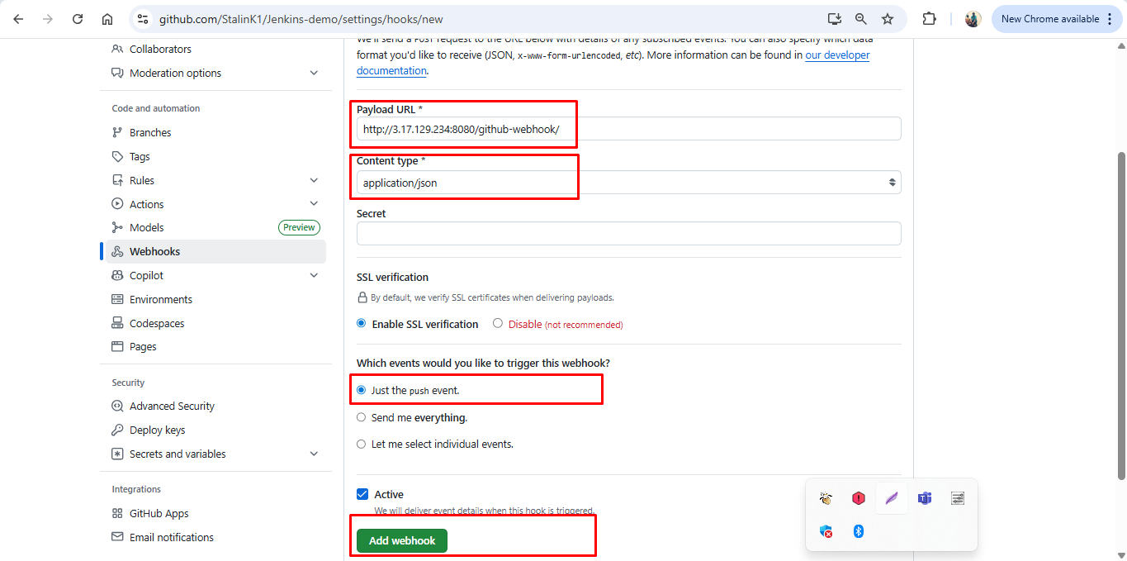

5.2

In Jenkins, Go to job → Configure → Build Triggers

Check -> GitHub hook trigger for GITScm polling

Save the configuration.

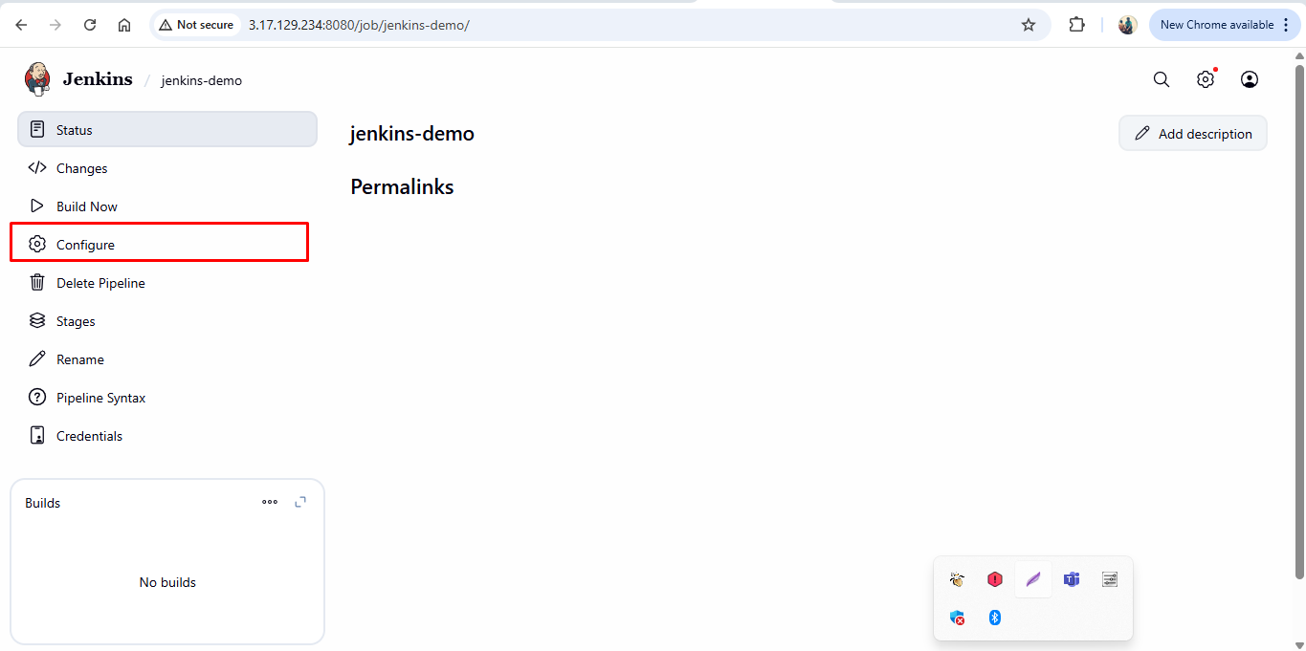

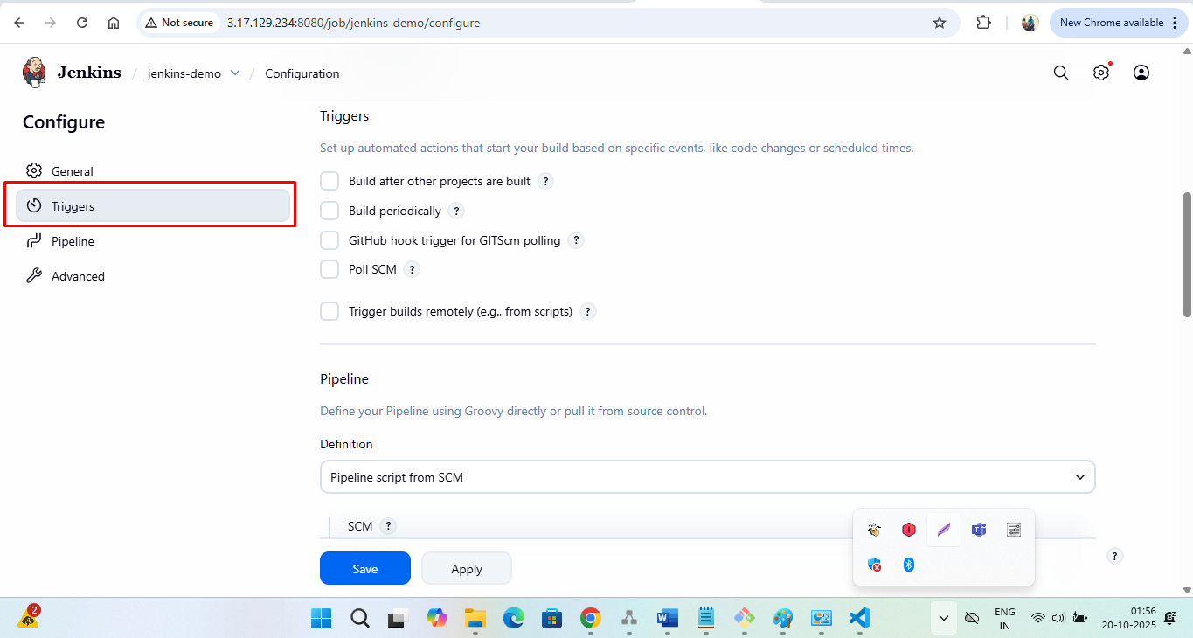

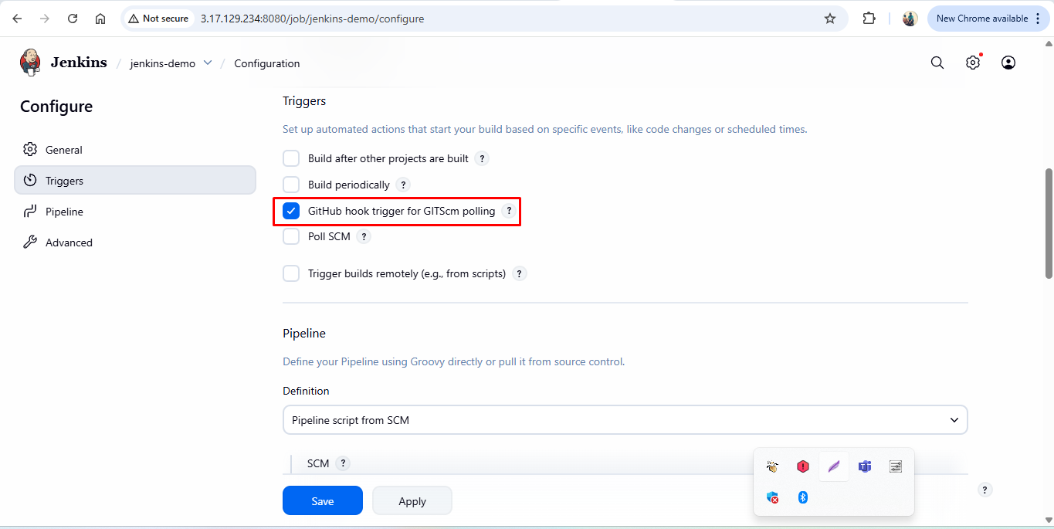

Step 6: Configure Email in Jenkins

Go to Manage Jenkins → Plugins → Available

Install Email Extension Plugin

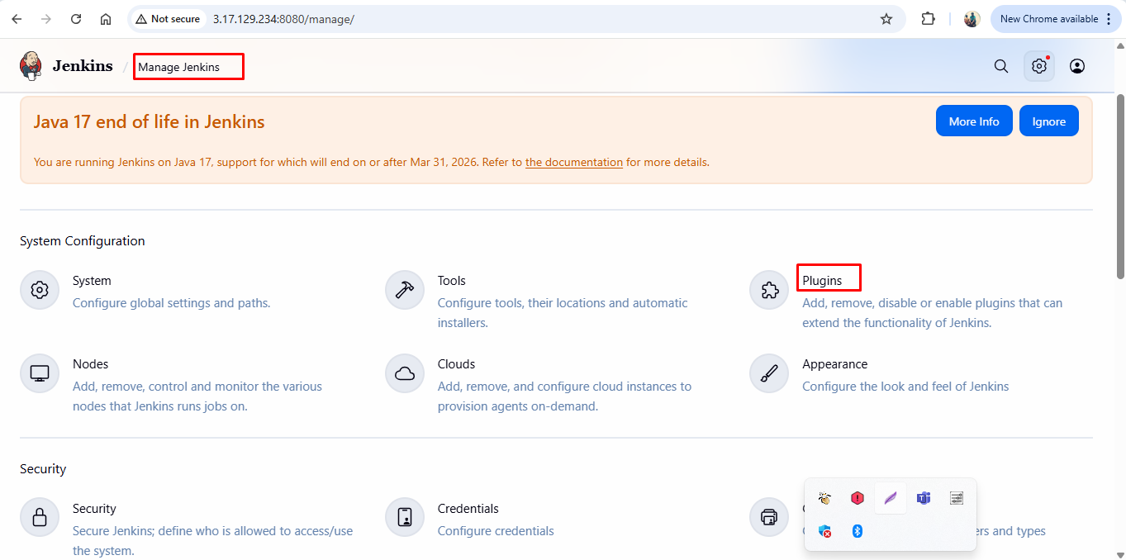

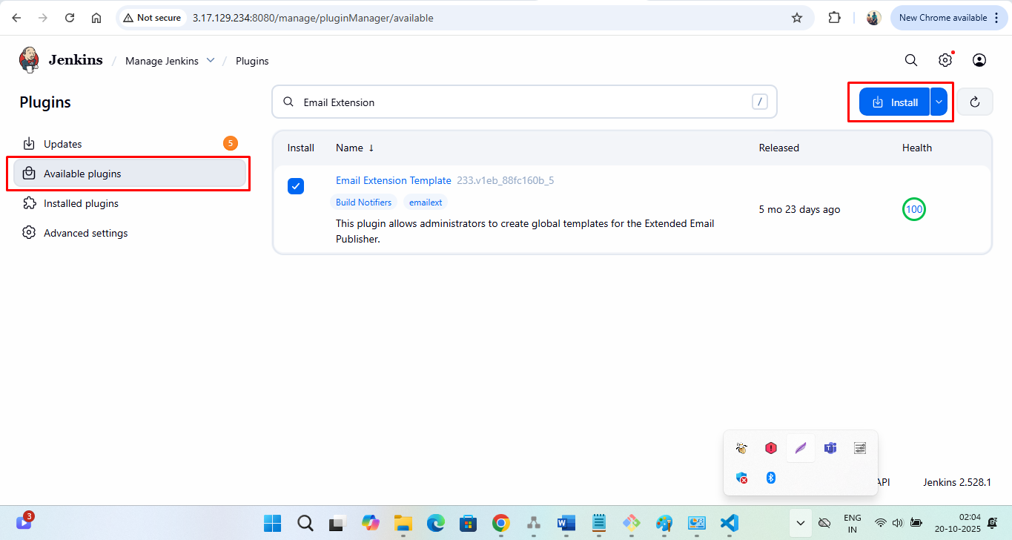

After installing plugins, restart Jenkins.

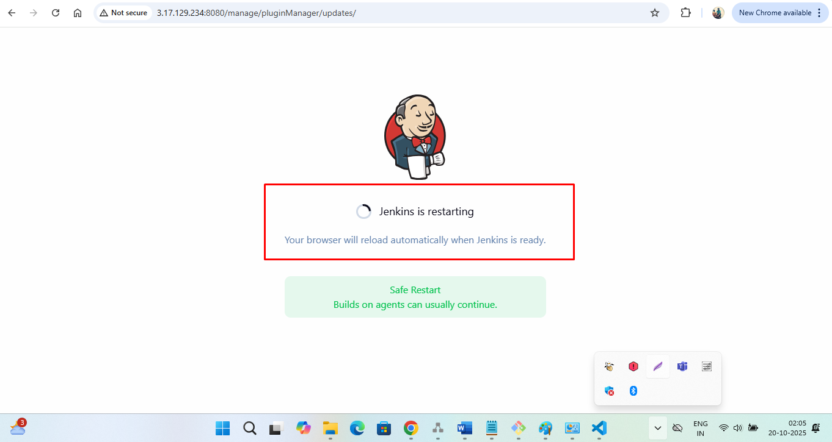

6.1: Verify the installed Plugin.

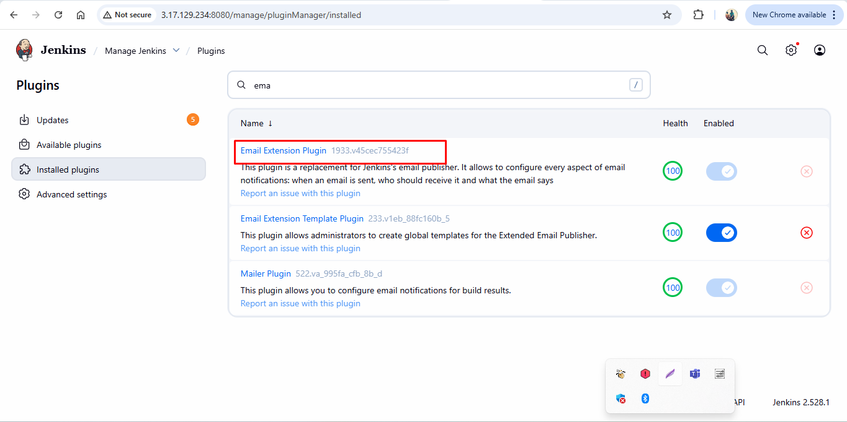

6.2:

Configure SMTP:

Manage Jenkins → System → E-mail Notification

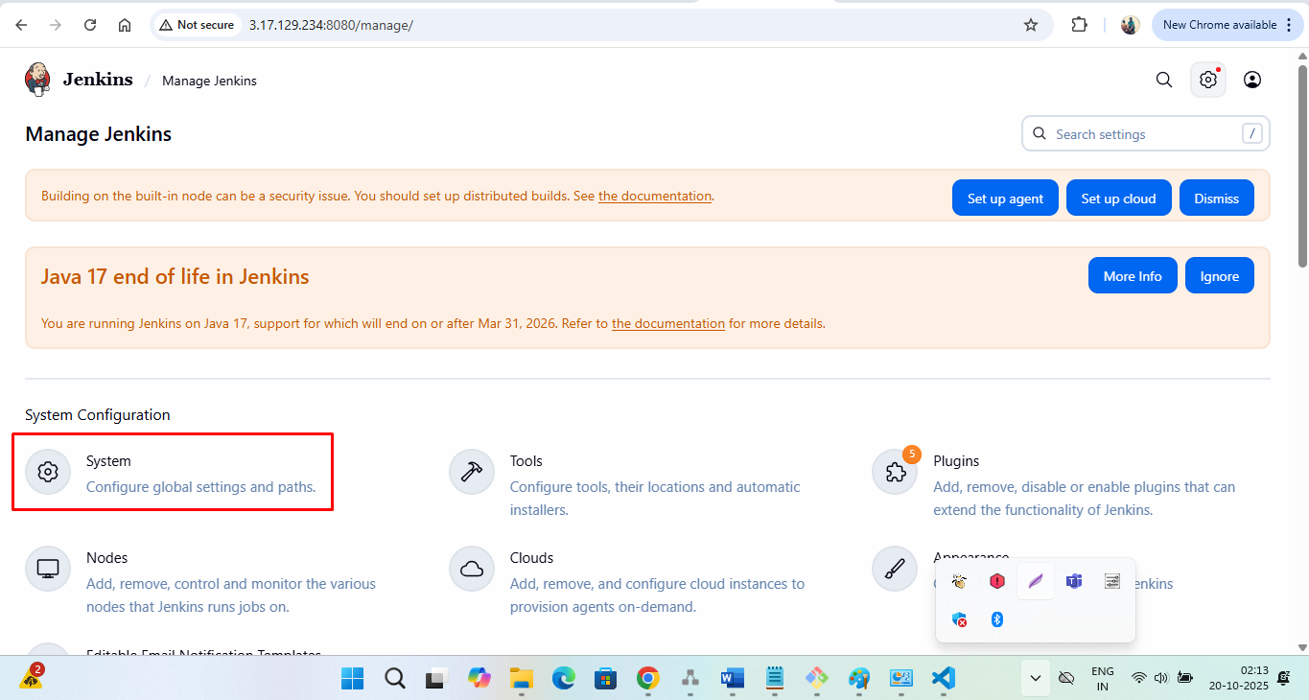

SMTP Server - smtp.gmail.com

Default user e-mail suffix - @gmail.com

Use SMTP Authentication - (checked)

User Name: stalin.kumaragiri@gmail.com

Password: Paste the App Password you generated

Use SSL - (checked)

SMTP Port - 465

Reply-To Address (optional): same Gmail ID

Charset UTF-8

**How to create App Password:**

Goto your account.

<https://myaccount.google.com/u/2/?pageId=none&pli=1>

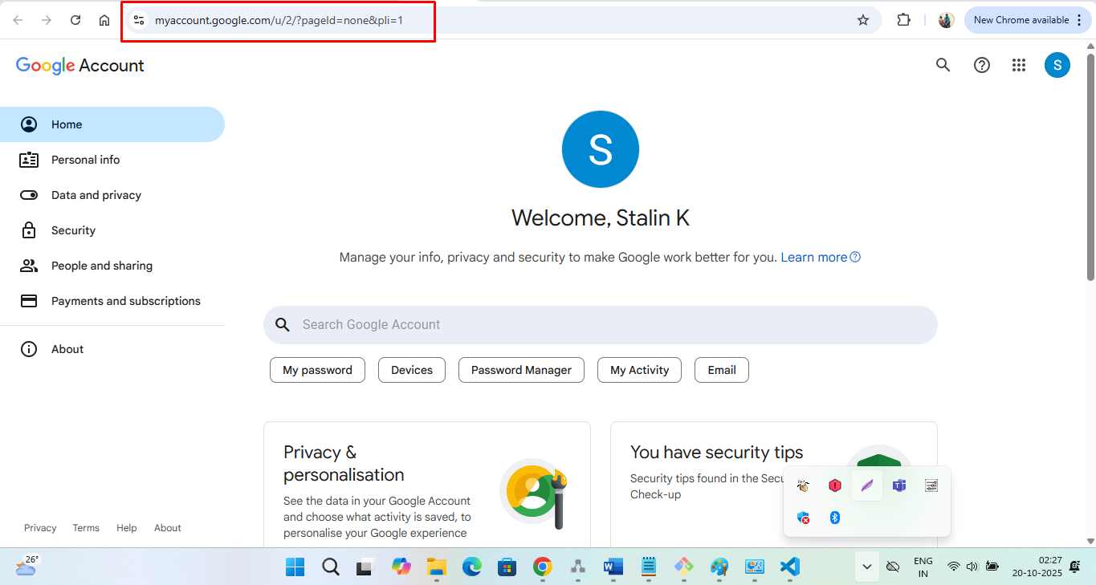

Enable **2-Step Verification** (if not already done)

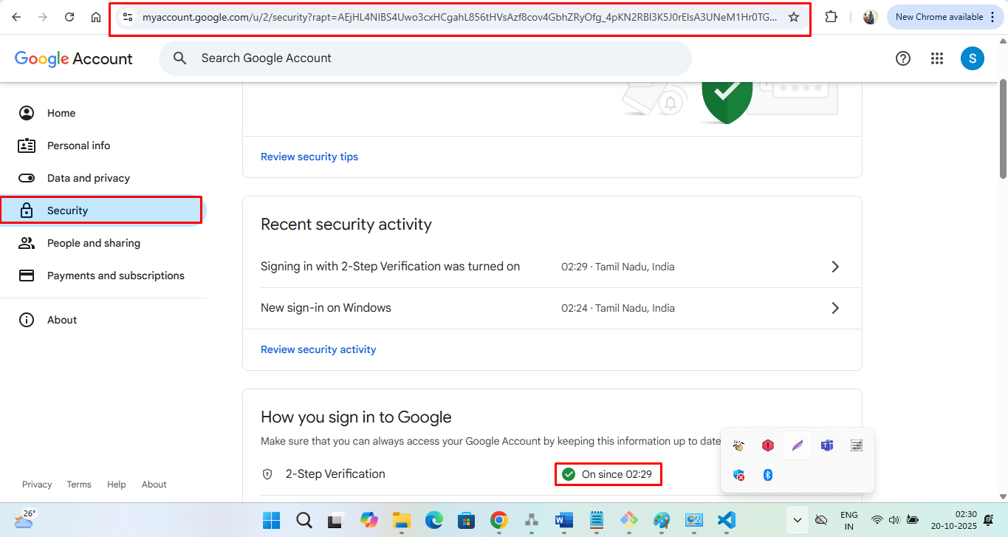

Navigate to:  
Security → App passwords

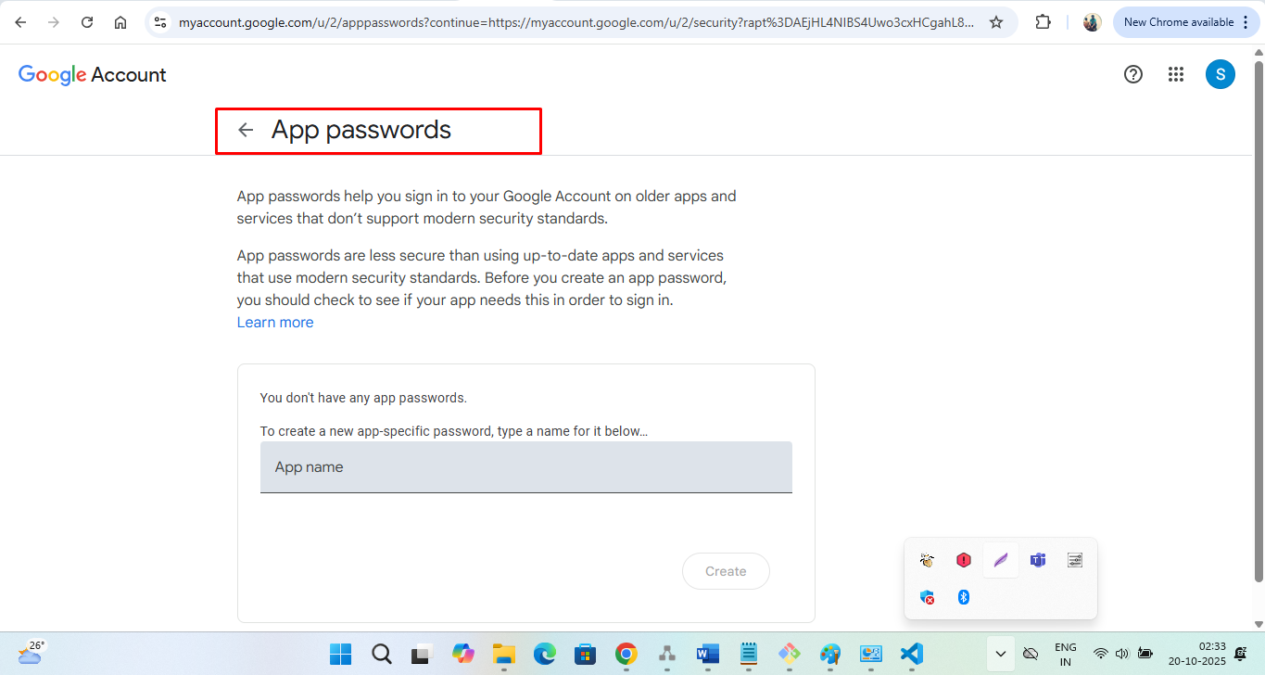

Choose:

App: Mail

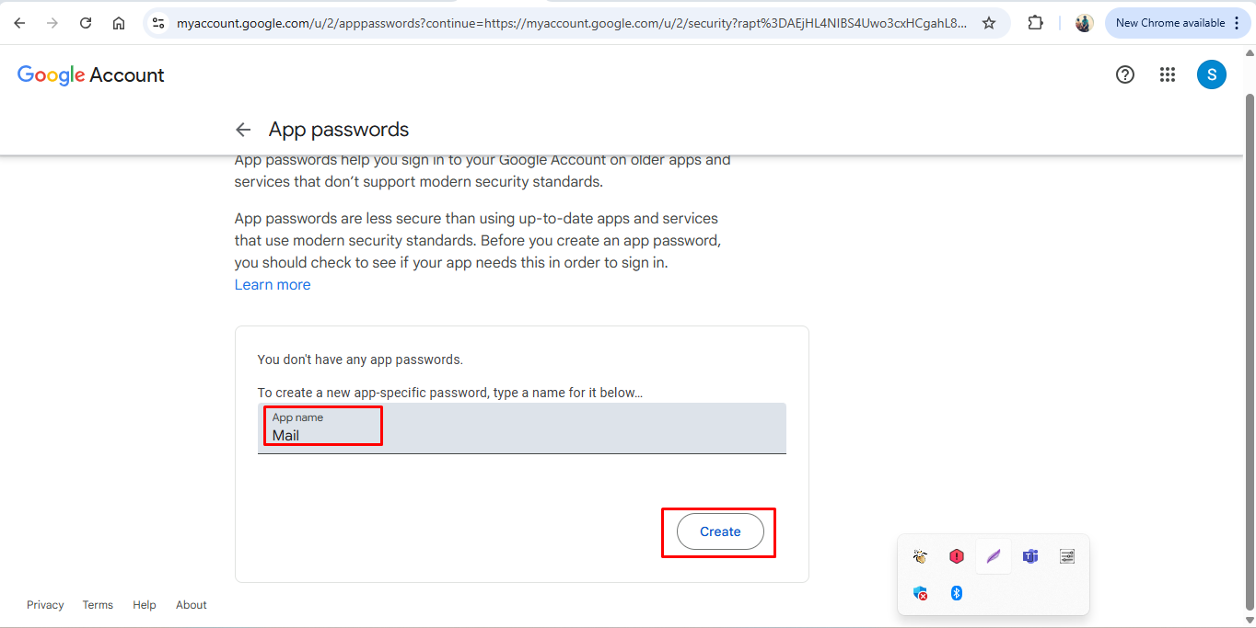

Google generates a 16-character App Password (e.g., abcd efgh ijkl mnop)  
Copy it and save it safely — you’ll use this in Jenkins credentials.

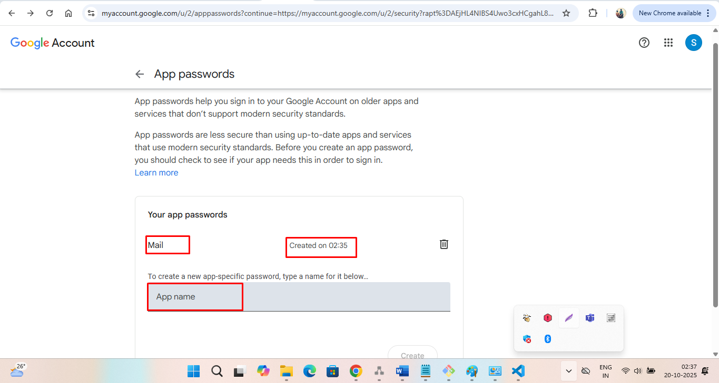

After Generating App Password - Returning to Step 6.2:

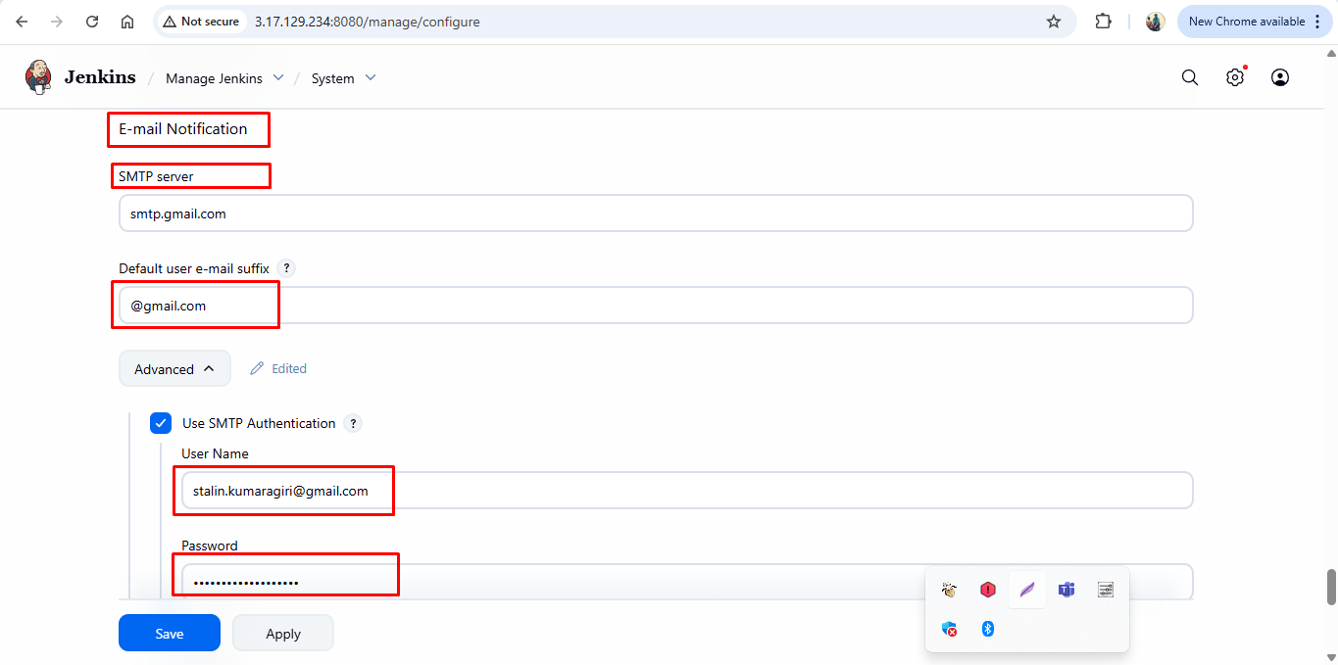

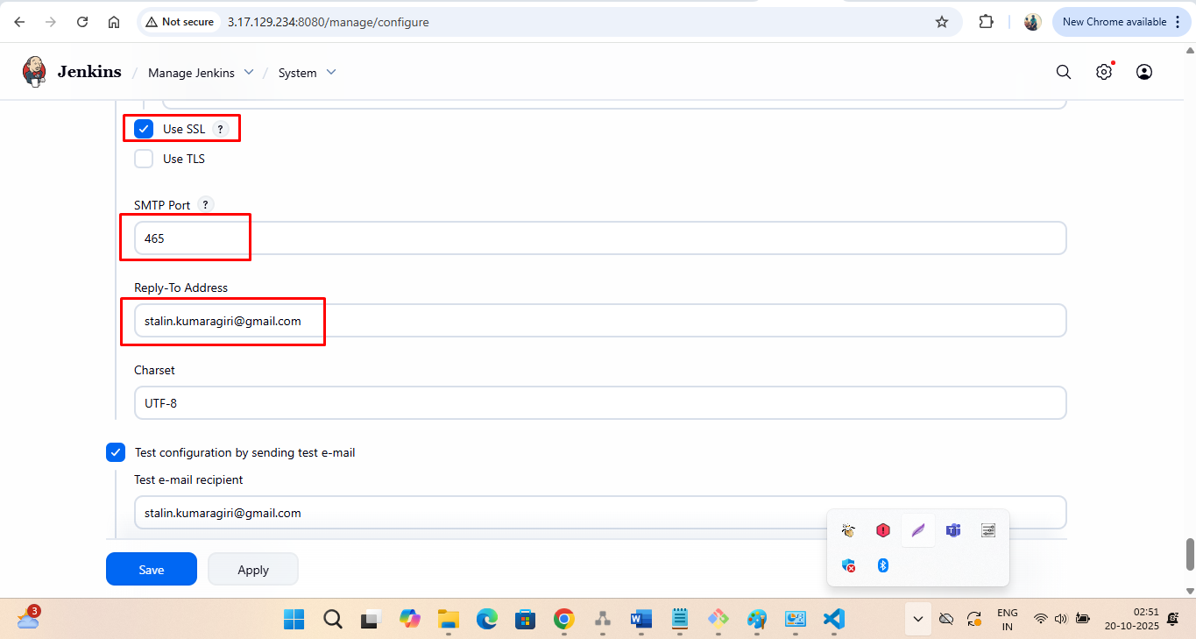

Testing the configuration:

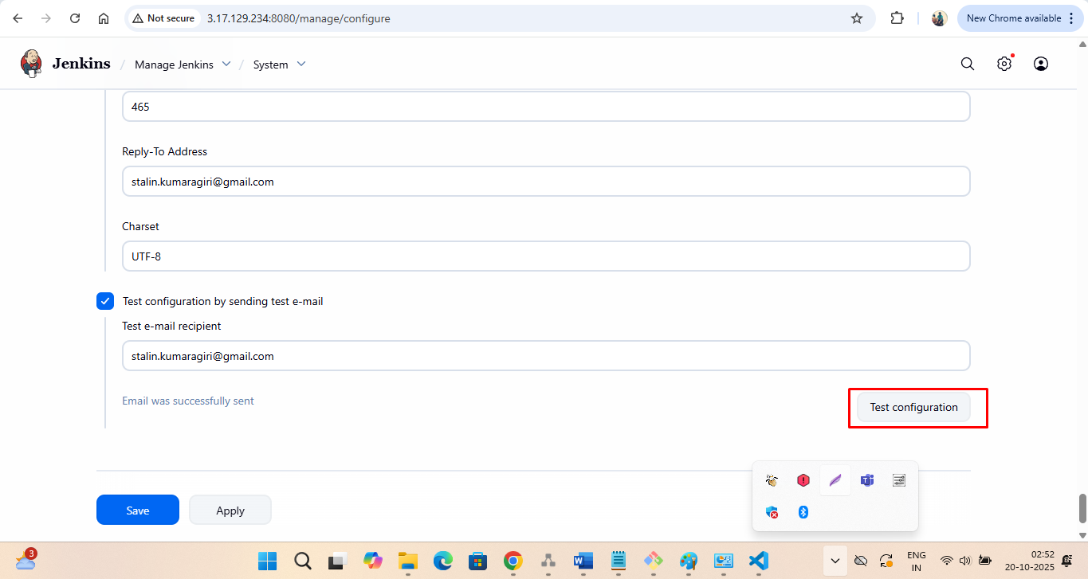

Test Configuration Successful:

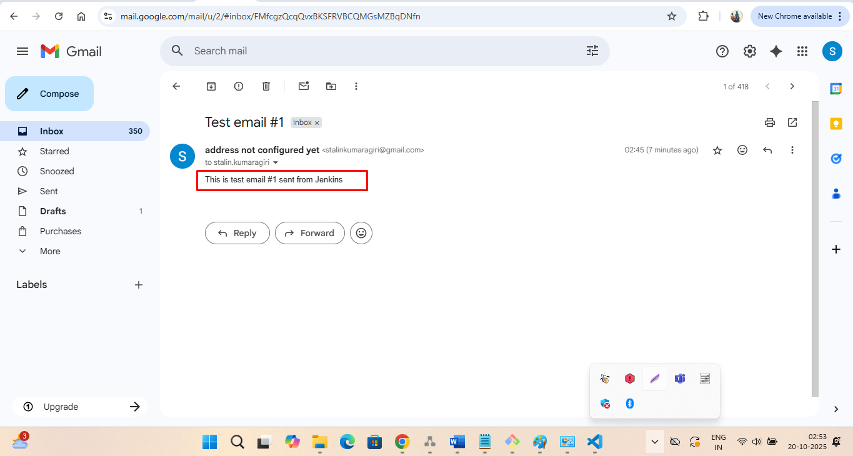

6.3: Save the configuration

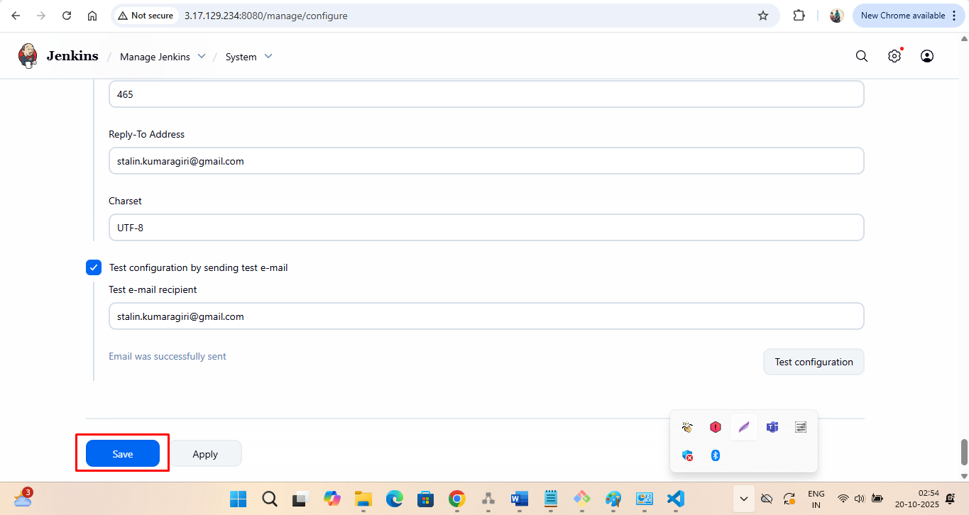

Step 7: Build the project now and show whether pipeline has been created.